**Google Form**

It is an application of Google Drive, in which you can make forms and surveys to obtain information on the opinion of a group of people, being a practical tool, through which you can perform a series of questions through surveys to obtain the desired information.

A survey carried out with Google Form will be use for the "BionicKitchen" project, to collect information from the employee´s menu every two weeks. The survey administrator will be an employee of OTSA (Obregon Technology Development Center); the administrator will be responsible for updating and sending the survey every two weeks, for the proper functioning of the project. The survey it´s saved in the Google Drive of the Google account of the administrator or OTSA (TBD); the survey can be share to another Google account, so somebody else can update it.

**Content**

**Content** 2

**Create Google form for “BionicKitchen” Project** 3

**Send Google Form** 9

**Collect answers** 11

**Answer survey** 13

**Problems/Limitations** 14

# **Create Google form for “BionicKitchen” Project**

**Manual step by step:**

**NOTE:** The information in the survey shall be in Spanish.

1. **Access to Google account** and go to the Google Form section.
2. Select **create a new Google Form**, in blank (Image 1):

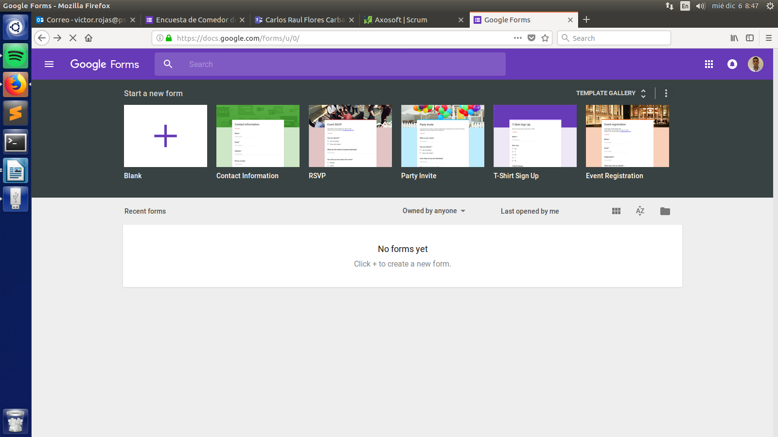

Image 1

1. The Image 2 is going to been shown, with the next information:

* **Survey name (Required):** Name of the survey, shall put the dates (next two weeks) of the BionicKitchen service.
* **Survey Description (Optional):** Text brief about what is the survey

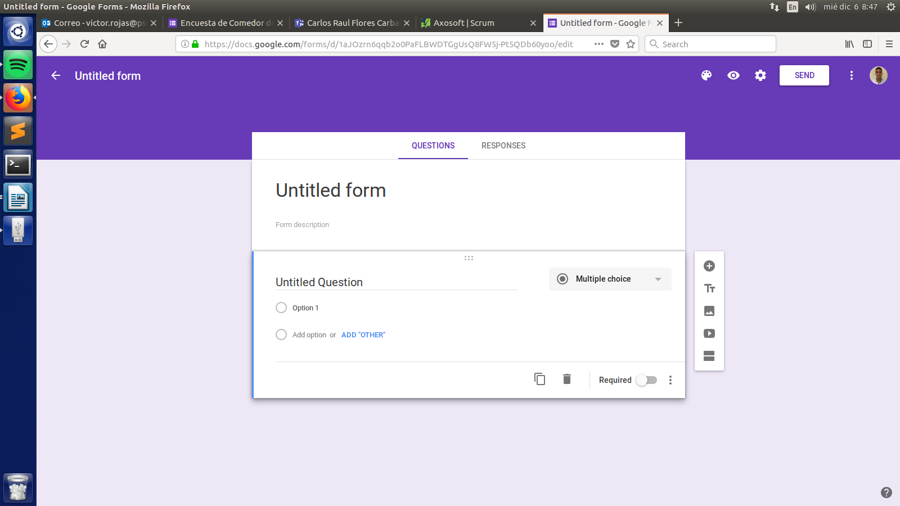

Survey Name

Survey Description

Image 2

EXAMPLE of the survey name and description (Image 3):

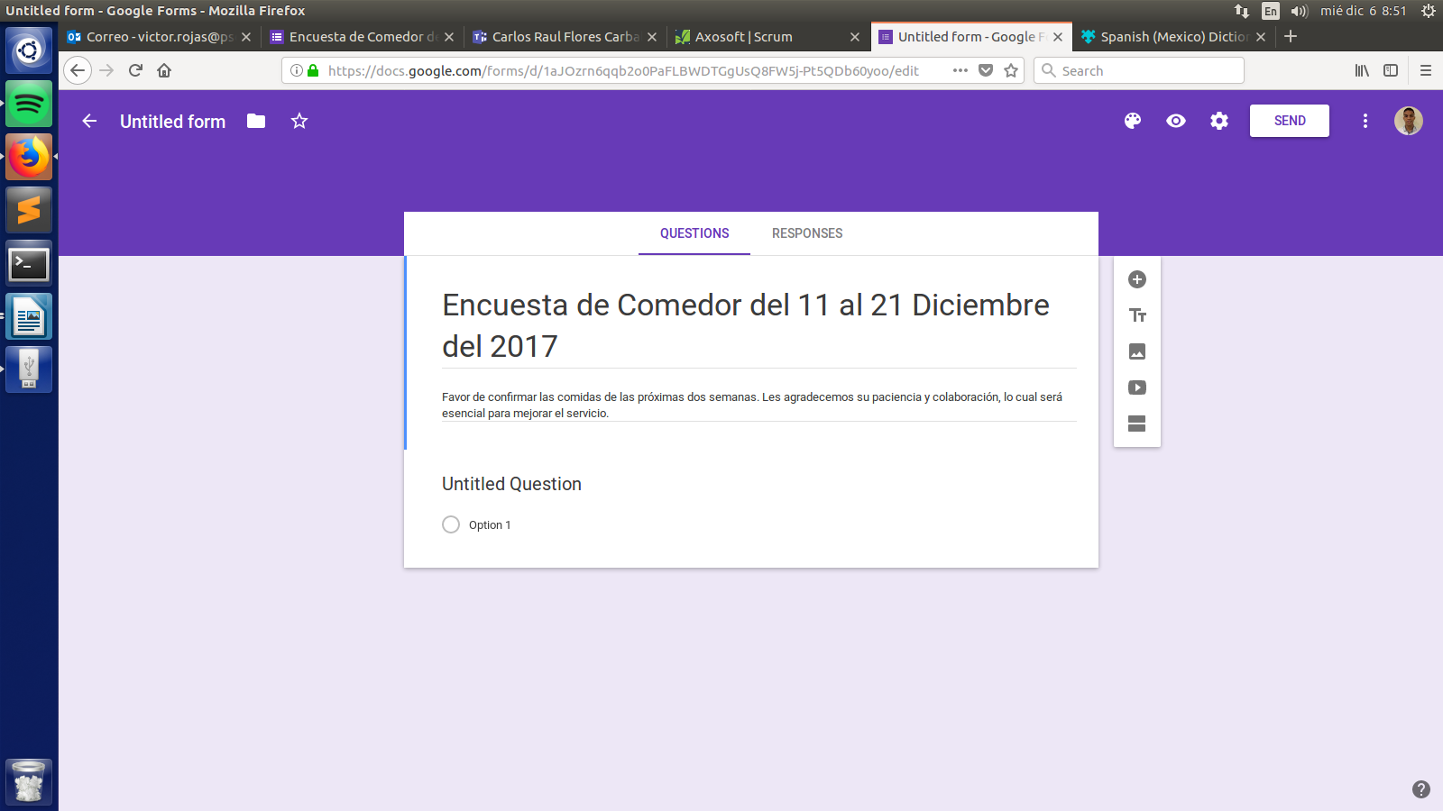

Image 3

1. **Name question:** the first answer of the survey (create automatically) is going to be the Employee´s/User name (Image 4)

* **Question name:** Shall be “Nombre completo”
* **Question type:** Select the option “Short Answer”
* **Required answer:** Select this option
* **Question description (Optional):** In case, add warning that the name must be complete and correctly written

Question name

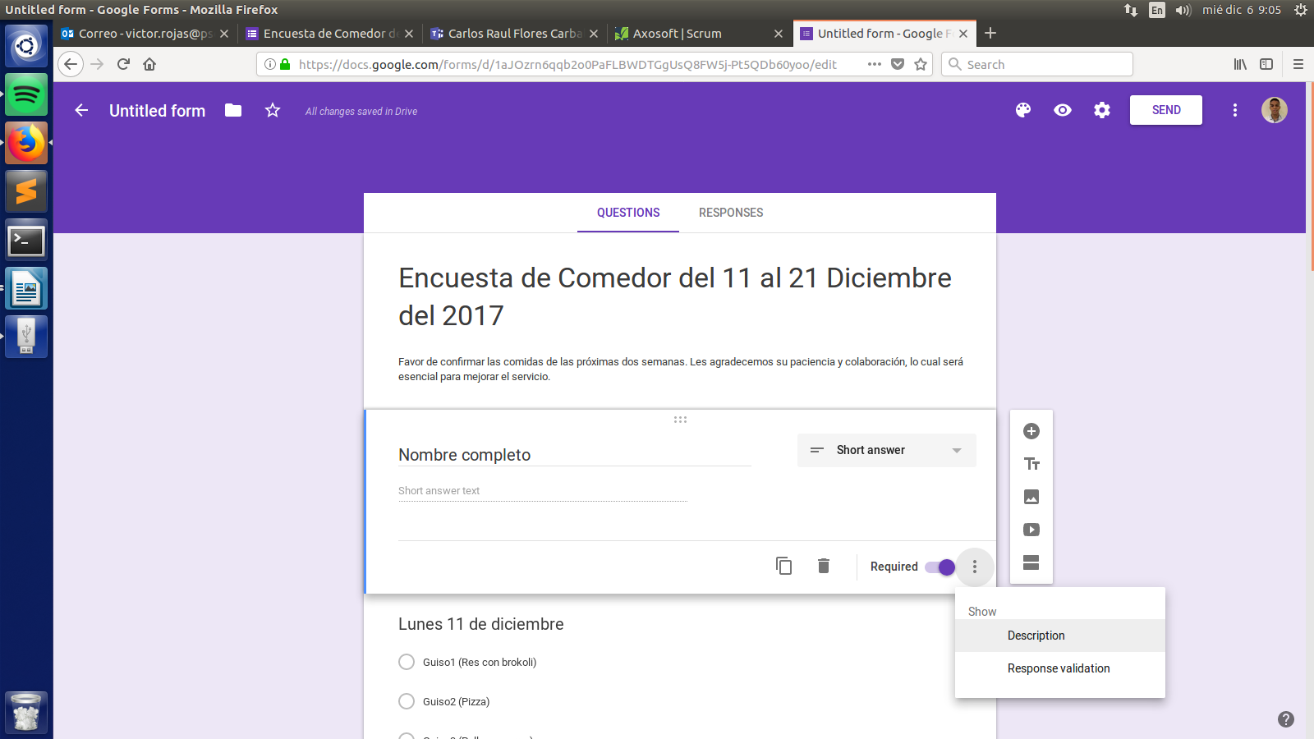

Required answer

Add question description

Image 4

EXAMPLE of Name question: (Image 5):

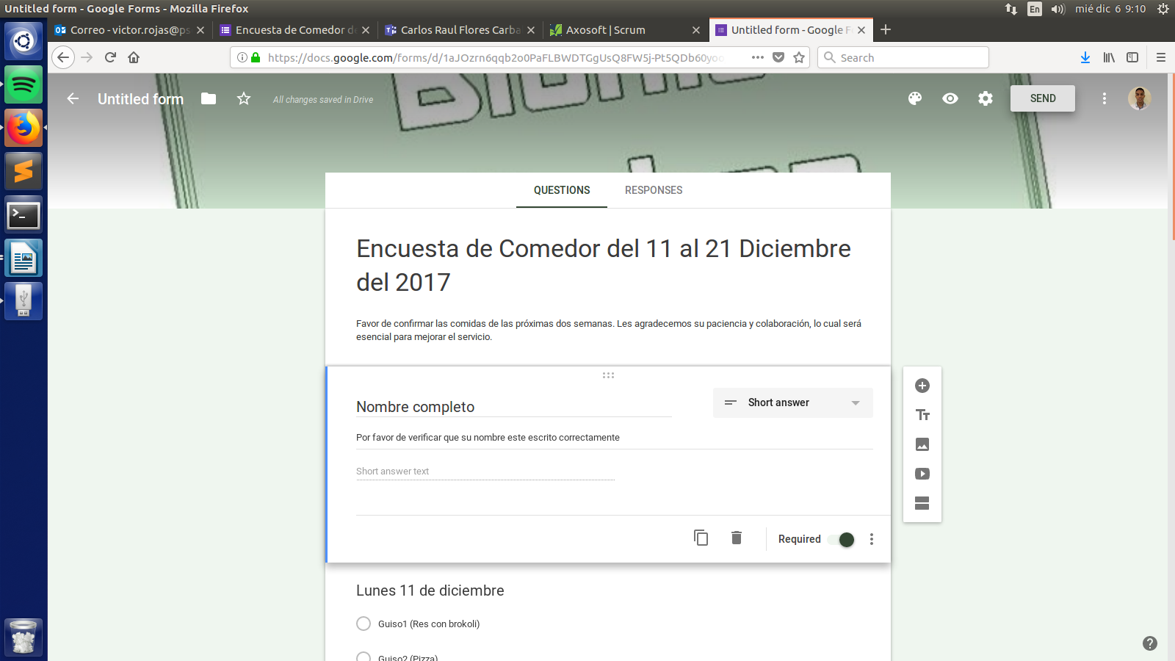

Image 5

1. **Add a new answer.**

* In the options bar located on the right side of the screen, clic on the first icon (Image 6)

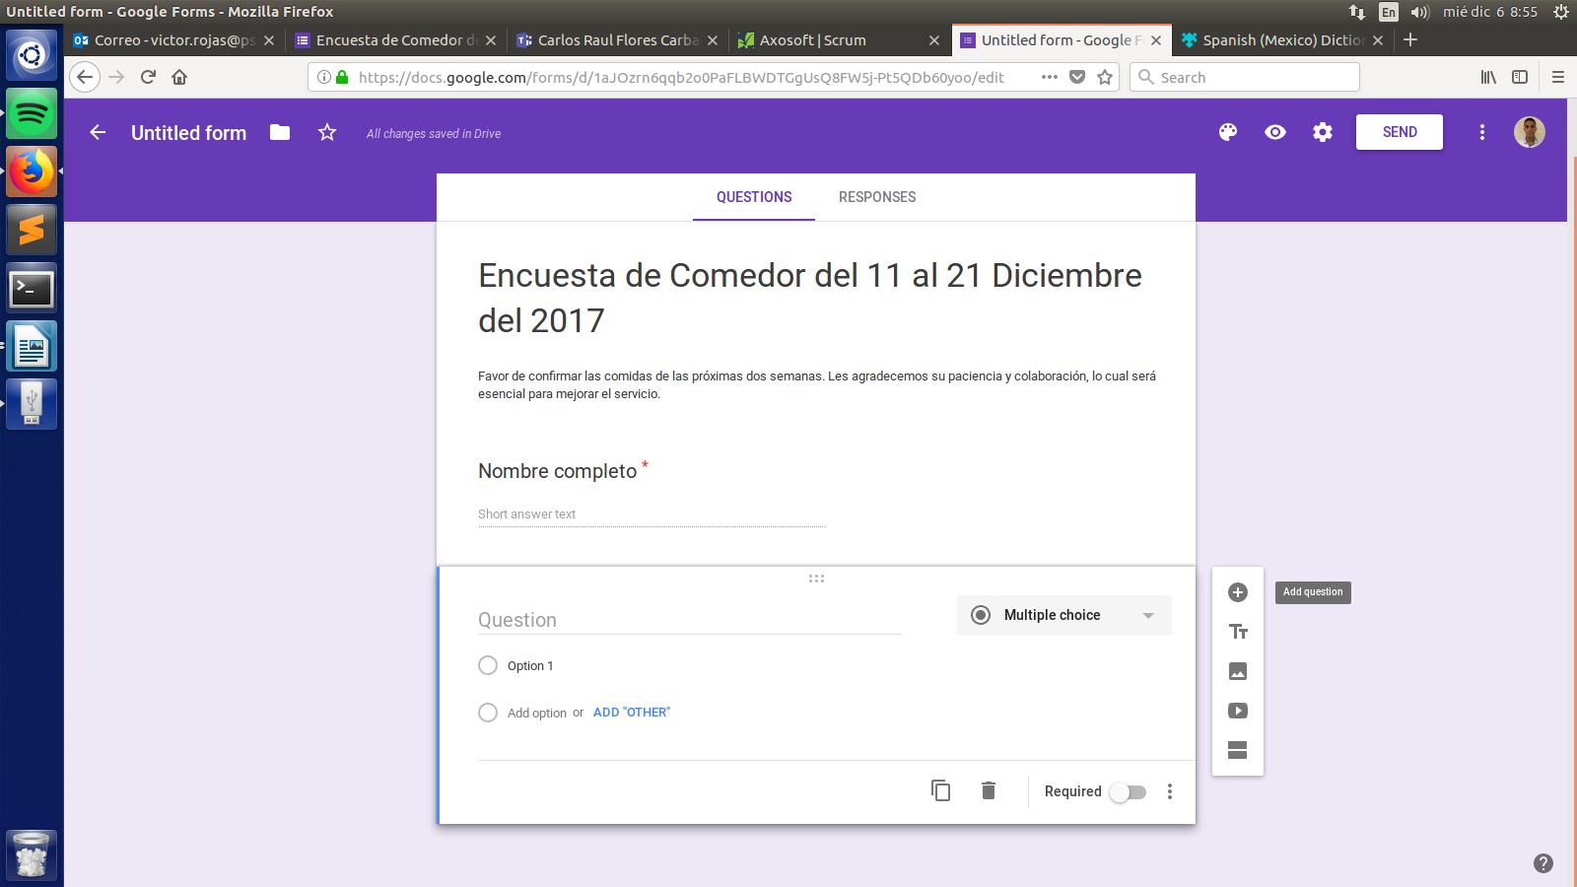

Image 6

1. The next step is create the **day question** that the BionicKitchen will offer service

* **Question name:** Shall be the date in this format:
  + Name of day (Only first letter in upper case)
  + Number of day
  + Preposition “from”
  + Month name (all in lowercase)
  + All in Spanish and respecting spaces
  + EXAMPLE: “Lunes 11 de diciembre”
* **Question type:** Shall select the option “Multiple choice”; each option will be able dish to choose for the respective day (only can choose one option). Shall be in this format the options (answers):
* Dish next to his number (without spaces)
* In brackets the name of the dish
* All in Spanish
* EXAMPLE: “Guiso1 (Res con brocoli)”
* **Required answer:** Don’t select this option, because the employees can decide don’t order service for the respective day.

EXAMPLE of first day question (Image 7):

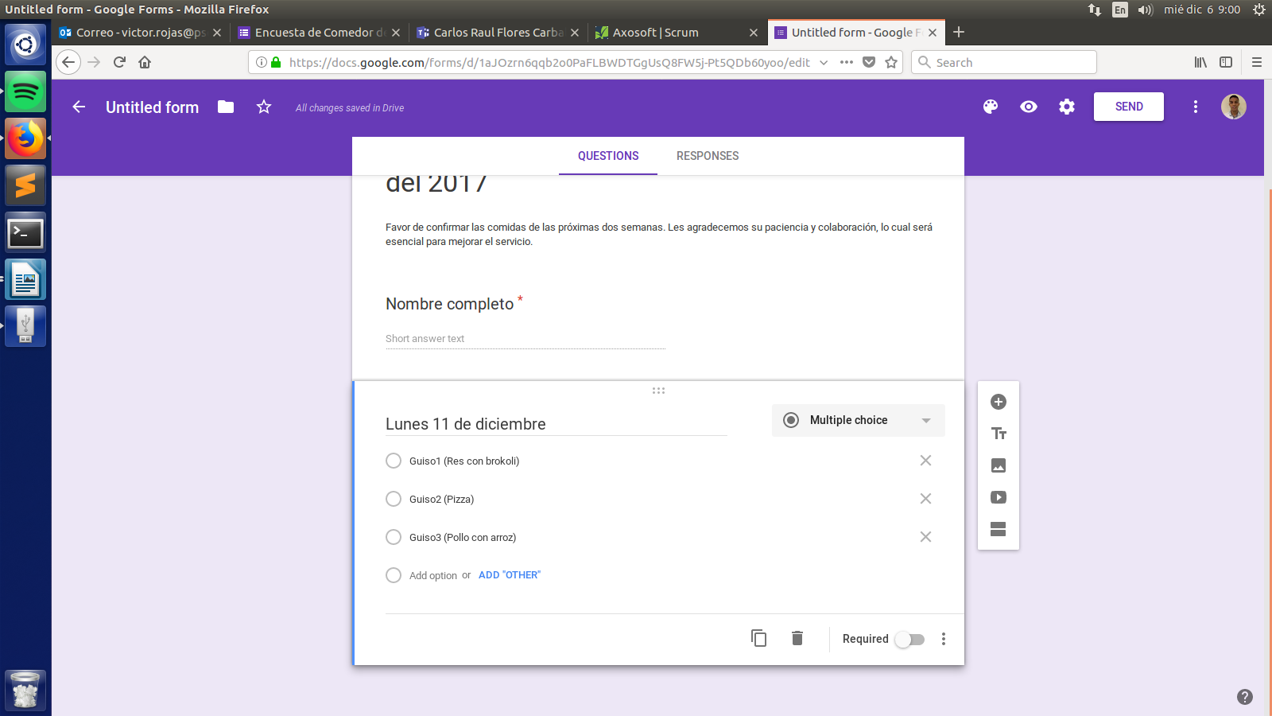

Image 7

NOTE: In case is need add another choice, only clic over “Add Option”, and type the new choice. (Image 7)

NOTE: Repeat this step for the next 7 days.

1. Add a **suggestion question** (Optional). This question is for employees suggest dishes that can be serve in a future.

* **Question name:** Shall be “Sugerencias”
* **Question type:** Select the option “Paragraph”
* **Required answer:** Don’t select this option. The employee isn’t forces to suggest a dish.

EXAMPLE of Suggestion question (Image 8):

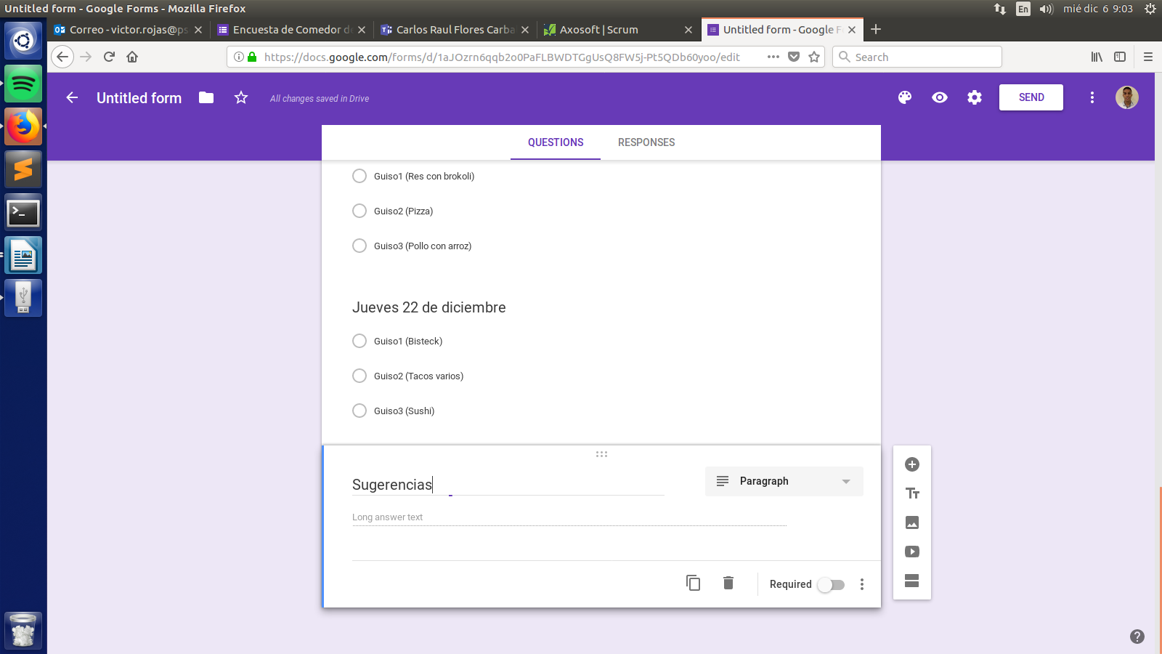

Image 8

1. **The survey is finish,** it save automatically in Google Drive**.**

**IMPORTANT NOTE:** If one day the BionicKitchen isn’t going to offer service, cause days of day off, or any reason. That day necessarily need to be in the survey for the correct function of all the programs of the BionicKitchen project. (At least the question has to go, even if the answers are in blank).

# **Send Google Form**

**Manual step by step:**

1. In the right op of the principal web page, clic in the botton “**Send**”. (Image 9)



Image 9

1. It will apear the window “Send form” shown in Image10:

* Ubicate the tabs in the top, and clic in the **second icon (link).** (Image10):

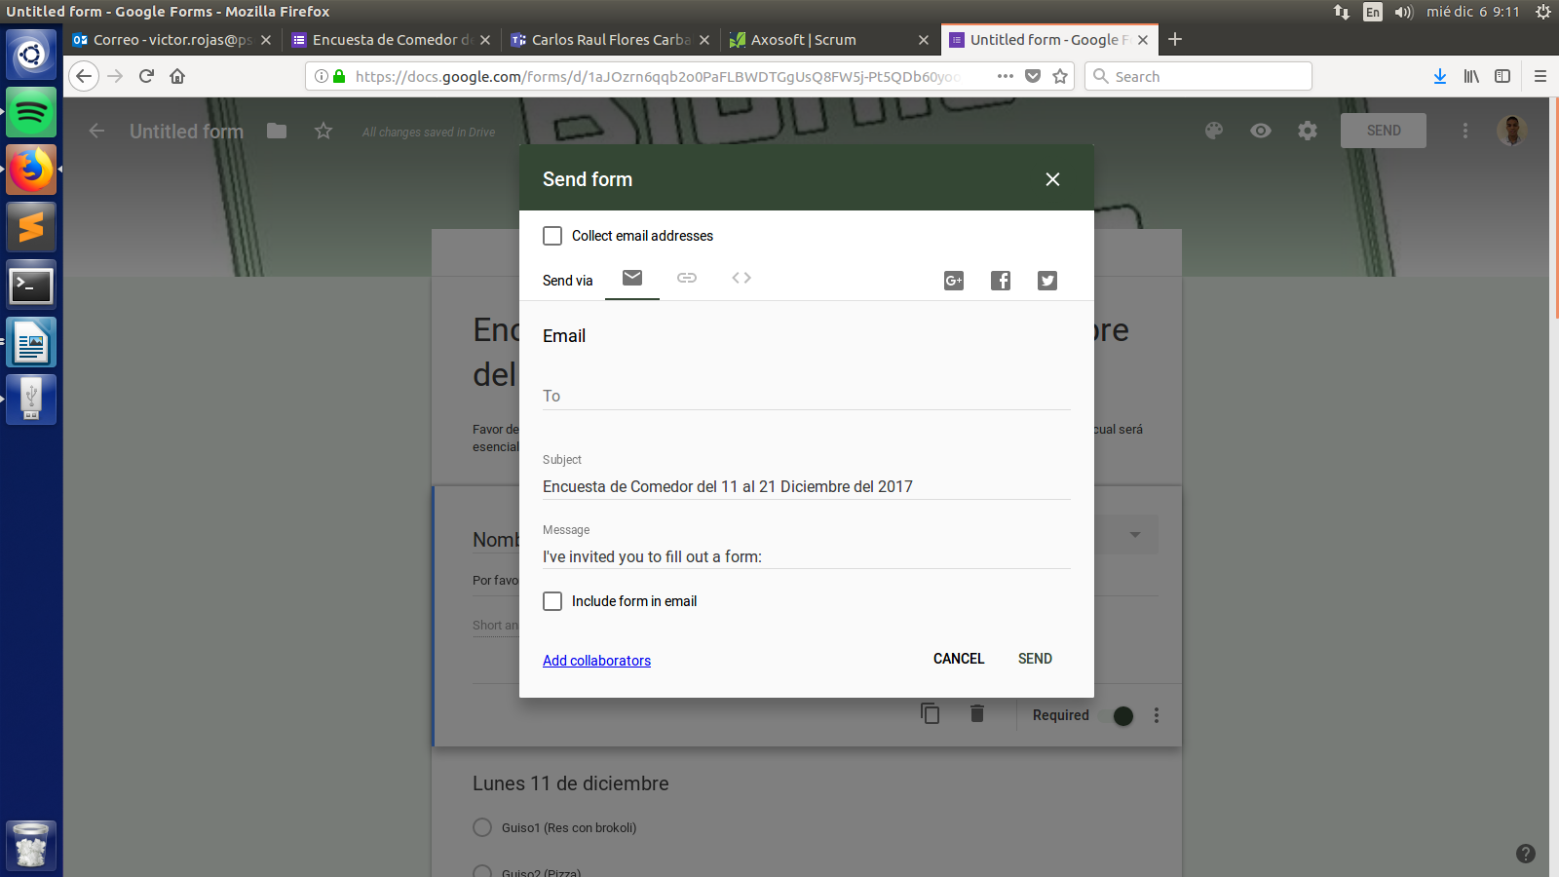

Image 10

1. It will appear the tab “Send form” shown on image 11

* Select option “Shorten URL” (Optional): that way the link will be shorter
* **Copy URL**

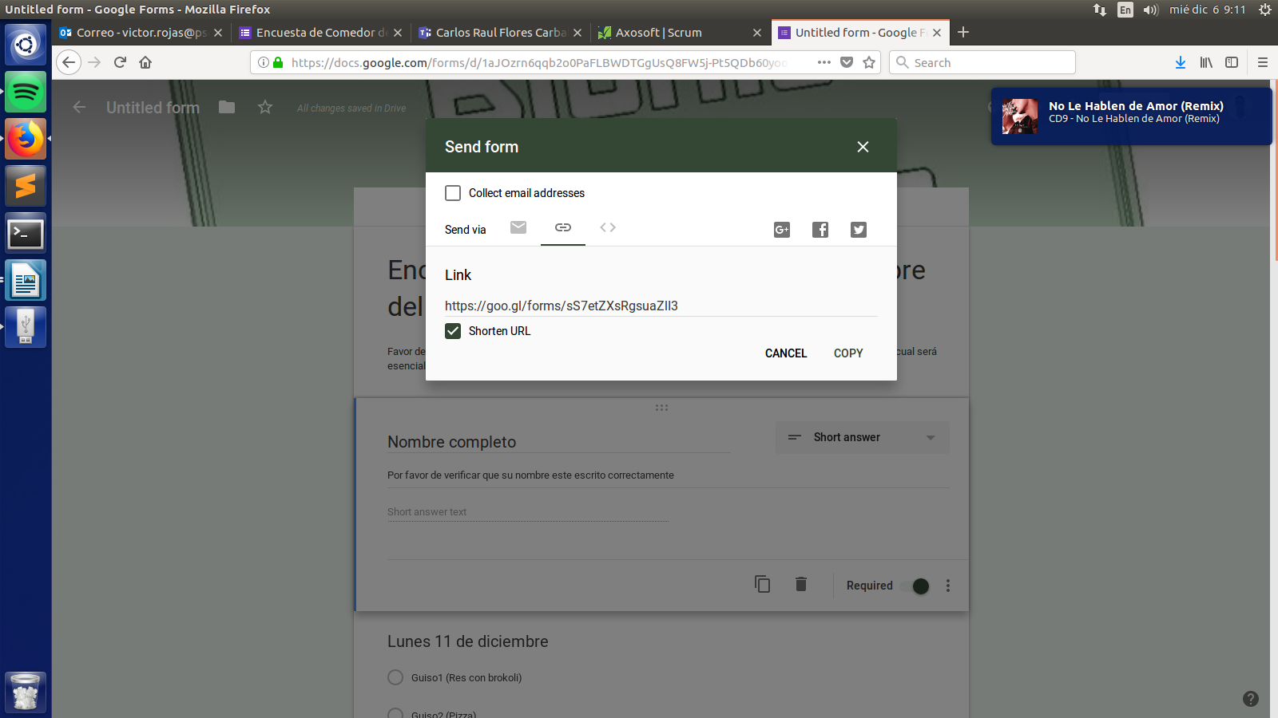

Image 11

1. Now can **send the URL** trough the appropriate way to the employees, so thay can answer it.

# **Collect answers**

**Manual step by step:**

1. In the top of the survey, there are two tabs, clic in the second (**Responses**)**.**

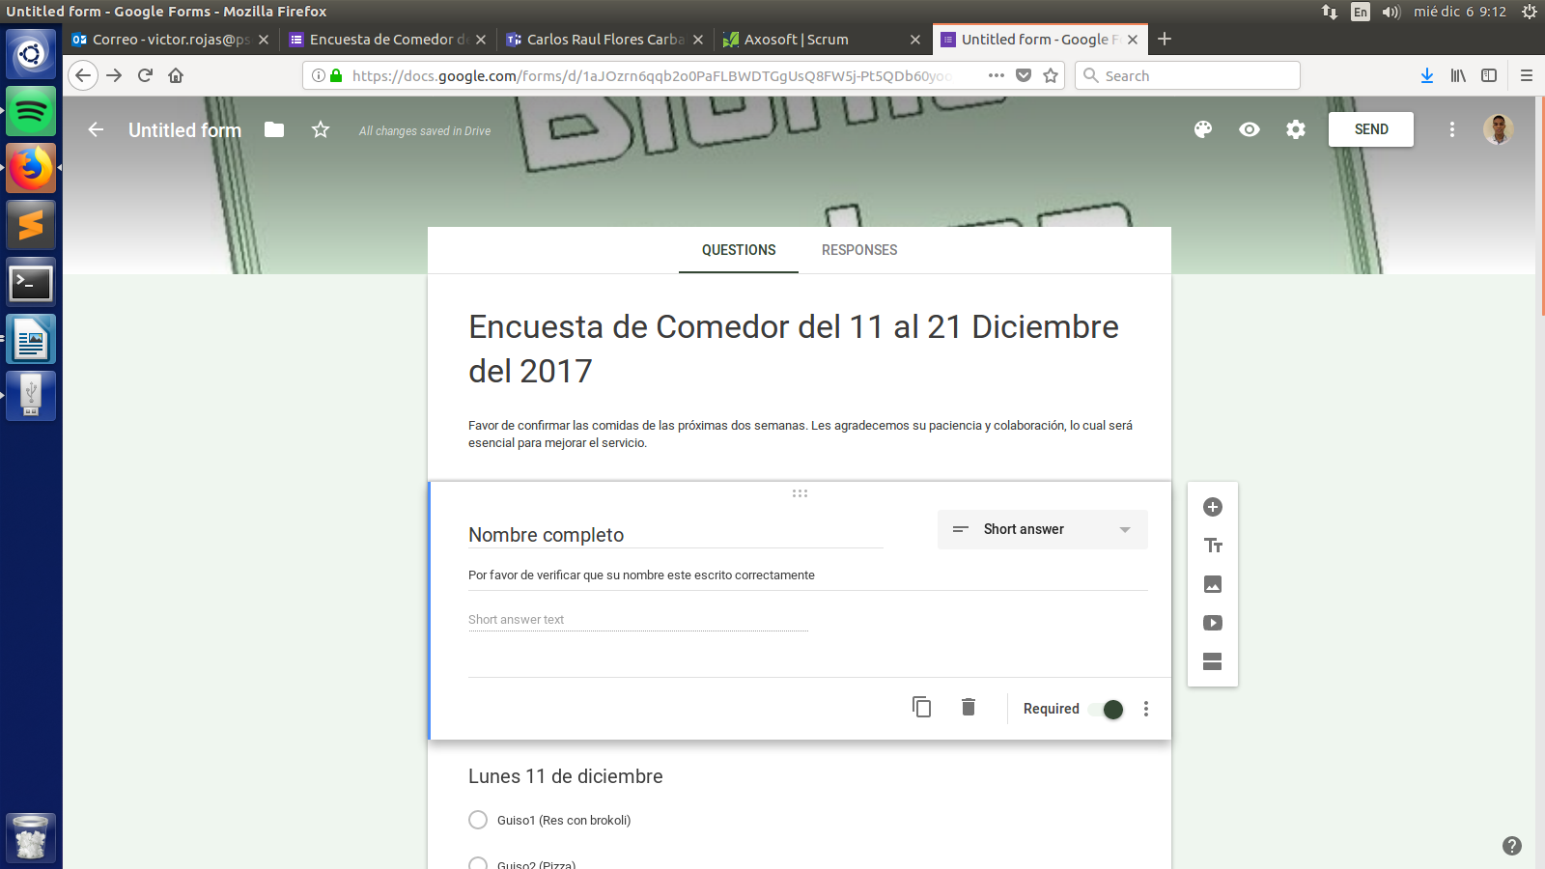

Image 11

1. In the tab “Responses” appear the employees who answer the survey, and a graphic of the answers of each day (Image 12):

* Ubicate the top right of the tab, clic in the **spreadsheet icon (green icon)**

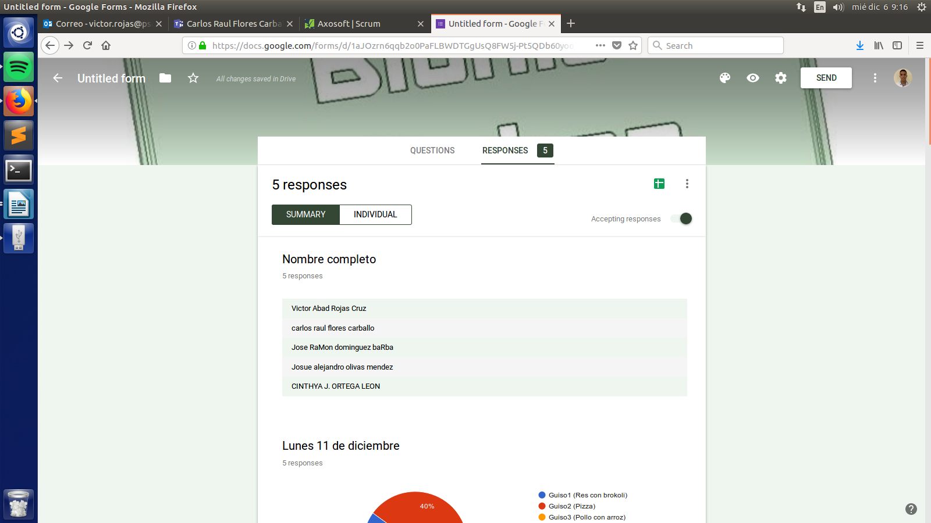

Image 12

1. It will appear the window “Select response destination” shown on image 13

* Select the option “**Create a new spreadsheet**”:
* The name of the spreadsheet exactly shall to be:
* “Encuesta_de Comedor”
* Clic in “Create”

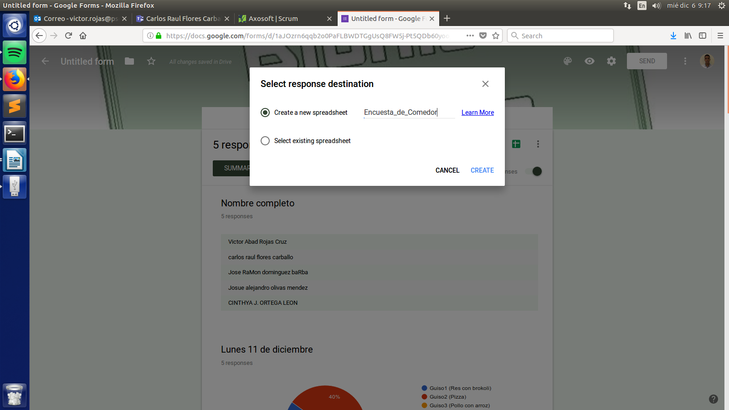

Image 13

1. **Open spreadsheet** (Image 14)

* Verify that all the information is correct (Ref. Answer survey).

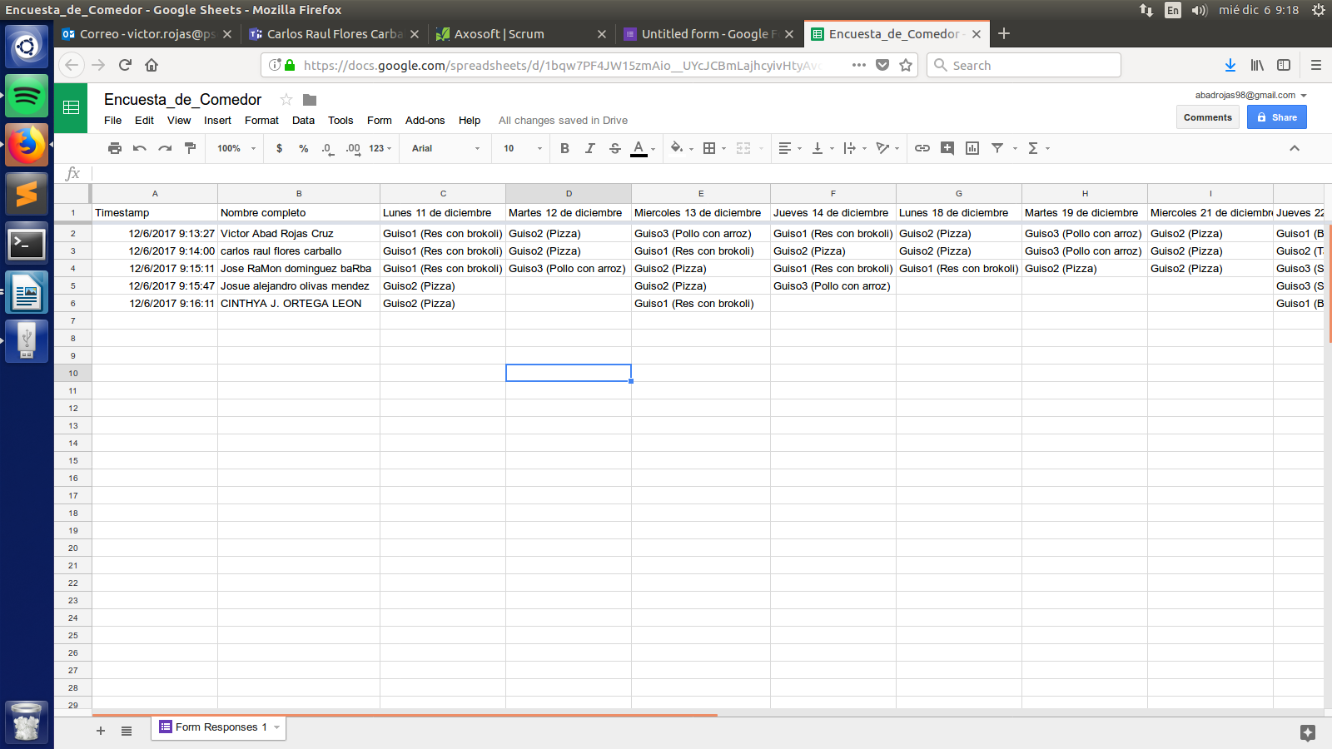

Image 14

# **Answer survey**

In this section is explain how to answer the survey, is important to notice all the employees the next information, for and optimum service.

**NOTE:** The administrator of the survey shall revise the answers, to notice the employee if is an error on his survey information.

The questions of the survey are:

1. **Name question (Nombre completo):** This question is for identify the employee that is answering the survey.

* Shall be the complete name (first name and last name)
* Shall be written correctly
* Don’t matters uppercase and lowercase letters.

NOTE: Important to verify that the answer follow the past indications.

1. **Day question (Pregunta para cada día):** This question is for select a dish for each day that the BionicKitchen is going to offer service.

* Shall select an option (dish)
* Shall be three options (each one is a dish able for the respective day)
* Shall be a question for each day of the week that the BionicKitchen offers the service
* Is a required an answer for all the questions (employee can decide not order a dish for a respective day)

1. **Suggestion question (Sugerencias):** This question is for suggest a dish, for be served in a future.

* Is an optional question (employee can decide to suggest a dish)

**IMPORTANT FOR THE ADMINISTRATOR:**

The only answer that can generate conflicts for the BionicKitchen project is the **Name question**, the rest of the answers are fill up automatically by the survey, at the moment that the employee select an option. So is important to verify the row of names in the excel document generate for collect the answers. If one name is written incorrectly, notice the employee. The employee could be able to answer the survey again, is doesn’t matters if the employee is repeated in the survey answers, if only one answer is correct.

# **Problems/Limitations**

The use of survey through Google Form for the project "BionicKitchen" can generate conflicts, since it is prone to human errors, either by the administrator or by the user (employee).

The administrator has to be very careful when modifying the form every two weeks, because if he does not respect the indications mentioned in this document, most of the project's programs will not be able to execute or will not do the correct function.

The user (employee) should try to provide his full name and written correctly, in this case it does not matter if the name is written in lowercase or capital letters, but the correct syntax is essential. If the user were to commit any of these errors, the service could not be provided.

The problem is that these mentioned limitations cannot be corrected or taken by means of Google Form. The solution is to correct information through scripts, or use some other automated method (eg Tokens)